Title: Teaching News Literacy using Online Technology
By Caitlin Genord
Rationale (Make sure you provide the rationale for your overall project here.)
I teach a non-fiction class to high school seniors. I am working on building in more media literacy skills into the curriculum. These lessons are tangible ways I can teach my students about news literacy. One of my courses is blended meaning students do half of their learning at home. These technology tools will make it easy to implement news literacy lessons at home and in-person.
Lesson One – Teaching News Literacy with Checkology—Lesson on News Bias
- A brief description of the #1 lesson plan (Purpose, subject, and grade plus any special information you need your readers to know)
Purpose: To teach students about bias in the news and how to use information fairly. Students will apply what they learn from this lesson to their research project. Expository Reading and Writing, 12th Grade.

- The technology and resources involved (e.g., facility, network, equipment, software, online program, apps, and websites’ URLs)
Students will need access to wifi and online network. They will be using a website called checkology.org. I made a class on the website and can easily share the information with them in class, so I can track their progress.

Here is a link to the e-learning resource: https://get.checkology.org/
3. What skills, knowledge, and pedagogy are required of teachers
Teachers will need to do some pre-teaching with students about bias and discuss the importance for their classwork. Teachers can and should preview the lesson on Checkology and determine what pre-teaching and follow up teaching will need to be done.
4. What prior skills and knowledge are required of students (both general and specific, think of Bloom's taxonomy)
Students will need to know how to use Checkology.org. It is pretty self-explanatory, but teachers should consider doing a short walk through of the program before sending students off to work. Students will need to understand how to apply what they learn from the lessons and should be able to comprehend and show understanding of content in the online lesson.
5. What are students asked to do exactly (product or process)
- Question #5 is a key question that needs more illustrations and explanations.
- You might provide a list of steps.
- You might provide external sources like links and videos.
- You might insert screenshots of apps, websites, samples.

- First students should be engaged in a discussion about bias in the news. Peak students interest in the topic by sharing some examples of bias.
- Students need to log in to Checkology.org and join using the class code.
- Students will go through the assigned lesson on bias in the news. There are 32 steps in the lesson. Some of these include watching videos, answering questions, role playing, etc. Here are some screenshots from the Checkology platform:
Here is video narrated by a real-world experts:

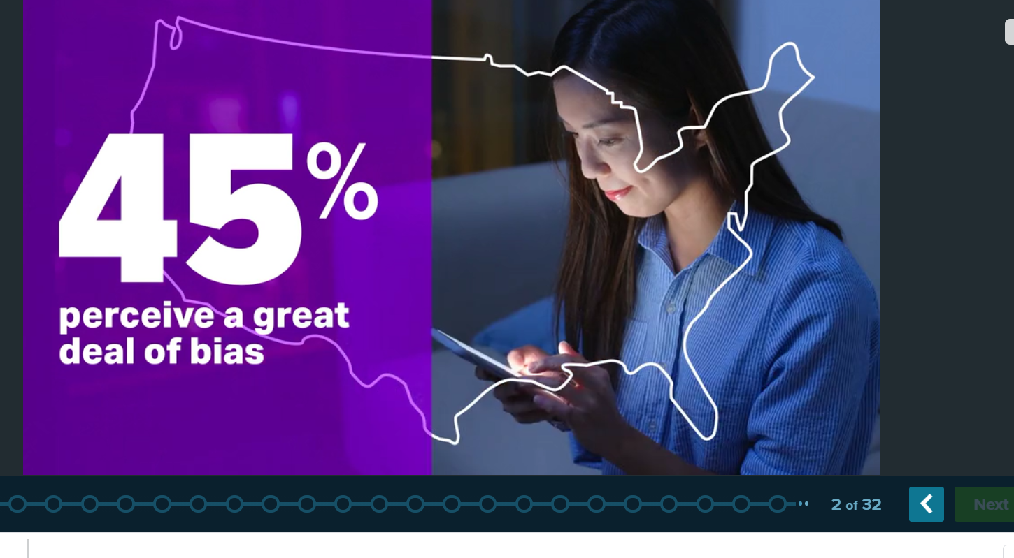
Here is an example of a question they ask students to participate in:
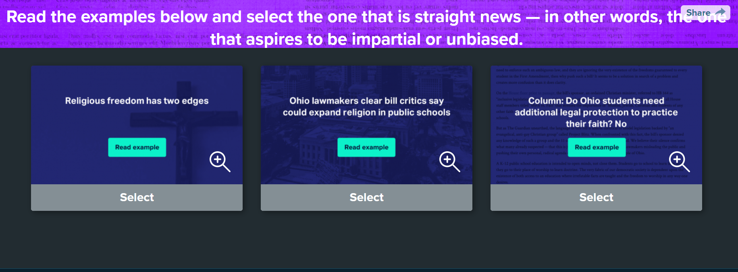
Here is an example of guided practice from the lesson where students have to identify the types of bias:
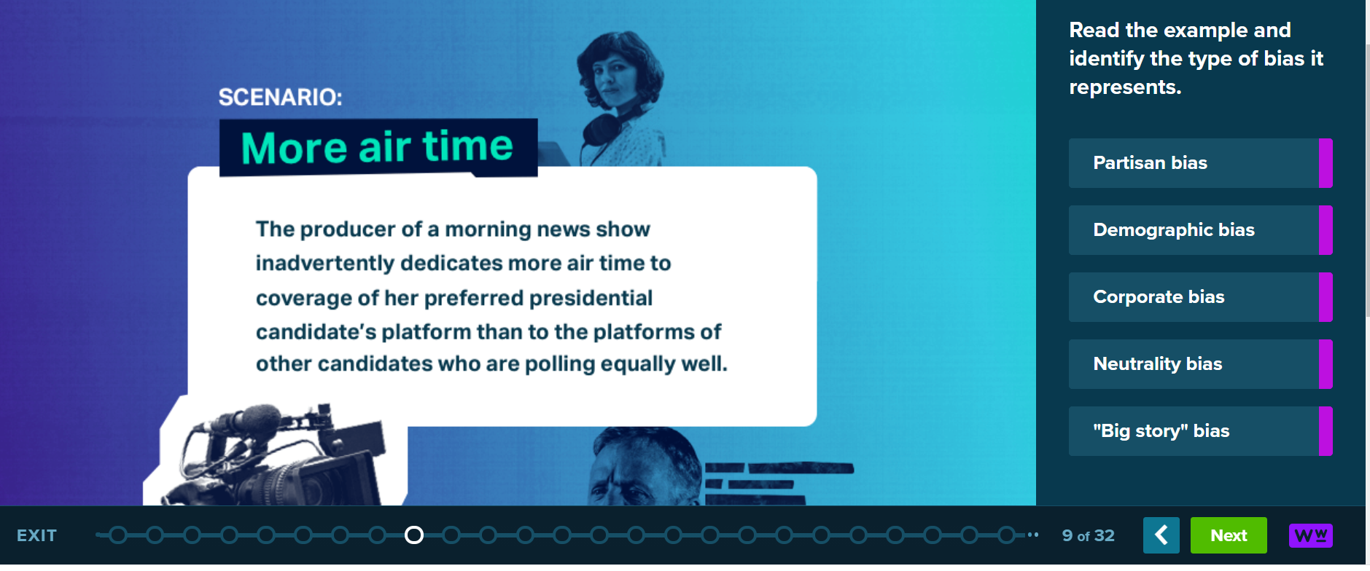

- Students should be able to complete the online work in one class period, and the following day, teachers should be prepared to do some follow-up work with students. Teachers can access the assessment data on Checkology to determine if there are concepts that need to be reviewed before moving on. The teacher should lead a discussion about these concepts to begin class the following day.
- Application to classwork: Students should now be able to apply what they are learned to their coursework. Students can use the CRAAP test to evaluate sources for their research paper. I use the following handout to go through this process with my students: CRAAP Test Template - Copy.docx
- After students evaluate their own sources, they will discuss what they found with a group of peers and submit their work for grading.
6. What are the procedures of the project (steps to teach the technology skills)
- Question #6 is a key question that needs more illustrations and explanations.
- You might provide a list of steps aligned with the project.
- You might provide external sources like links and videos.
- You might insert screenshots of information that provides visual illustrations.
- At the beginning of the lesson, teachers should give students a preview of the work they will do with Checkology.org.
- Students will log in and join using a class code.
- Students can ask for help or work with peers along the way for support.
- In a blended course, students could complete the checkology lesson at home.
- The follow up work will require the teacher to review the CRAAP test and explain the importance of each part. The teacher should consider modeling this for students.
- Students will need to know how to identify an article that could be used in their project.

7.What are the advantages of the project

- Checkology is reliable source that uses real examples from the news media world.
- Checkology lessons can be completed in class or at home!
- Teachers can monitor student’s progress, so they can determine if there are concepts that need to be re-taught
- Teachers can easily implement follow-up activities that pertain to the curriculum.

8.What are the disadvantages of the project
- Checkology is a bit more hands-off than a lesson that is teacher created. The content cannot be altered, so there may be parts of the lesson that do not feel as relevant for your students.
- The lessons can be a bit repetitive
9. What types of effective instructional strategies are included
- Modeling
- Class Discussion
- Application and guided practice
- Formative Assessment
10. What are the possibilities that innovation can be transferred to other teachers, subject content, and different school settings
- Checkology is useful for teachers in many different content areas. Any content that uses news, may find checkology lessons that pertain to their content area. The lessons are very easy to preview and work very well for blended and remote learning environments.
A list of sources used
- CRAAP Test Template - Copy.docx
- Checkology.org by the News Literacy Project

Lesson Two – Teaching News Literacy using Common Sense Media—Challenging Confirmation Bias
  - A brief description of the #2 lesson plan (Purpose, subject, and grade plus any special information you need your readers to know)
This purpose of this lesson plan is to teach students what confirmation bias is and to help students avoid confirmation bias in their own research. This is meant for 12th grade Expository Reading and Writing students who are working on a research paper. A portion of this lesson is taken from Common Sense Media, and the other portion is my addition.
2. The technology and resources involved (e.g., facility, network, equipment, software, online program, apps, and websites’ URLs)
Teachers will need access to the internet and students will need individual computers and internet access also.
Teachers must be able to access Common Sense Media for additional lesson resources.
Teachers will need to show the KQED video for the whole class.

3. What skills, knowledge, and pedagogy are required of teachers
Teachers will need to be able to describe confirmation bias and use examples. Teachers should be able to explain why confirmation bias is important and how it impacts our understanding of media. Teachers should also be able to direct students to resources for their research portion of the lesson.
4. What prior skills and knowledge are required of students (both general and specific, think of Bloom's taxonomy)
Students will need to know how to locate reliable sources on their research topic. This will have been taught in previous lessons in the unit. Students will need to self-reflect on their own biases and find gaps in the research they have done so far. Ultimately, students will apply what they learned about confirmation bias to their own project, to assure they are presenting a well-rounded view.

5. What are students asked to do exactly (product or process)
- Question #5 is a key question that needs more illustrations and explanations.
- You might provide a list of steps.
- You might provide external sources like links and videos.
- You might insert screenshots of apps, websites, samples.
- Begin by hooking students on the topic. Show students 3 different websites and ask them which is not credible. Give them time to discuss in pairs or groups which site they believe to be not credible. Here are a few sites suggested by Common Sense media:
    - "Japan finally abandons microwave ovens by 2020"
    - "New iPhone will come with a holographic keyboard and projector"
    - "Australia to introduce 33 different genders on passports"
- If using the sources from Common Sense Media, teachers will explain that all three websites are actually not real. However, most students will guess website #2 is real because of confirmation bias. The headline about iPhones best fits with what we already know about iPhones.
- The teacher should then give students and write it down the definition of confirmation bias: a tendency to interpret information in a way that affirms what we already believe.
- Next, show students a video created by KQED: “What Would It Take To Change Your Mind About Something You Really Believed?” https://learn.kqed.org/discussions/15
- Engage students in a conversation about confirmation bias and whether it could cause us to believe in “fake news.”
- Next encourage students to start a list of some of the biases they might have. Share some of your own to help them get started.
- Now that students have identified some of their personal biases, ask them to thing about how that might pertain to their research topic. What biases do they have about their research topic? What is their opinion on their topic? What experience/prior knowledge do they have about their topic?
- Now that students have studied confirmation bias and have an idea of how it may impact their research, help your students to find balanced research. Challenge them to spend the remainder of class time discovering a source that offers a new perspective on their topic or the opposite perspective of other sources they have collected.
- Students should discuss the fresh perspective resources they found in class with their partner or group and submit the resource with their sources.
6. What are the procedures of the project (steps to teach the technology skills)
- Question #6 is a key question that needs more illustrations and explanations.
- You might provide a list of steps aligned with the project.
- You might provide external sources like links and videos.
- You might insert screenshots of information that provides visual illustrations.
  - First students will exhibit their skills of determine credibility by taking a look at news headlines.
  - Students will need to demonstrate understanding of confirmation bias after watching a video as a whole class
  - Students will then have to write a list of their own baises and think about how that might pertain to their project. They will identify gaps in their research.
  - Students will need to find a resource to fill the gaps they have in their understanding of their topics. They will need to know how to use databases and search terms to find credible articles for their research.
  - The teacher will review the resources for students to find credible sources. For me, this means reviewing the search terms, and reminding students about our school provided databases.
  - Teachers should be available for students during the research portion of the lesson to help them find information they need to move forward with their project.
7.What are the advantages of the project?
    - Students will apply their learning about confirmation bias to the project they are working on in class.
    - Students will discuss in groups and as a full class to gain a complete understanding of confirmation bias.
    - Teachers can provide a lot of support during the practice portion of this lesson.
8. What are the disadvantages of the project
- This lesson will be more difficult to implement in a blended or remote setting.
- Students may have a hard time identifying gaps in their research or their own biases. They may need extra guidance during this portion of the lesson.
9. What types of effective instructional strategies are included
- Discussion (Peer and full class)
- Instructional video
- Research
- Conferencing
10. What are the possibilities that innovation can be transferred to other teachers, subject content, and different school settings
Other teachers who teach news related topics should consider teaching this concept. The more students are aware of their own biases, the more likely they are to seek out well-rounded opinions before sharing information.
A list of sources used
https://www.commonsense.org/education/
https://learn.kqed.org/discussions/15
https://www.commonsense.org/education/digital-citizenship/lesson/challenging-confirmation-bias#

