Ms. Genord English Language Arts Syllabus – English 3
Father Gabriel Richard High School— 2016-2017

Room # LL106 Email: cgenord@fgrhs.org
Office Phone Number: 734-662-0496 X242 Class Page : Rediker
What Will I Learn?:
Course Description:
In this class we will study language in four different forms through growth in reading, writing, speaking and listening skills. The purpose of this course is to provide 11th grade students with experience in close reading, analyzing, and writing about visual and traditional texts. Students will become familiar with different genres of literature and their functions. We will use language to apply meaning to our lives. Lastly, we will identify literature that best suits our interests!

Long Range Goals and Assessments: (What should you be able to do by the end of the semester?)
- Collaborate effectively in both the small group setting and in class discussions.
- Participate actively by listening intently and speaking for yourself.
- Monitor your comprehension of texts by applying reading strategies.
- Express yourself creatively in speaking and writing.
- Demonstrate personal growth in beliefs and opinions.
- Develop a purpose for exploring and thinking critically about texts.
- Evaluate and use information fairly to promote original thinking.

Big Ideas About Learning:
- Studying English Language Arts contributes to our development as better human beings, so it is important to seek personal growth from the material we encounter.
- Language is all around you—Give yourself a purpose when dealing with it (in reading, writing, speaking and listening)!
- Real learning is sometimes unpredictable, open-ended, spontaneous and requires further inquiry.

Enduring Understandings: (The things you won’t want to forget)
- Reading and writing are universally important and are essential for lifelong learning. Reading helps us to broaden our perspectives—to walk in another’s shoes.
- Allow your own voice to show in writing. Be critical of the world around you, and express yourself freely. Your willingness to share contributes to the overall success of the classroom.
- Take charge of your own learning—be independent and creative.

Essential Questions: (to achieve mastery)
- How can I be an active participant? What is the best way to share my opinion?
- How do I determine a purpose for reading and writing? What does this look like?
- In what ways do critical thinking skills contribute to my growth as a learner?
- What are my strengths as a reader and writer? What are my weaknesses, and how can I improve?
- How can I demonstrate new understandings in groups or as an individual?

Grading Scale:

A | B | C | D&F
97%- 100% : A+ | 87%-89% : B+ | 77%-79% : C+ | 67%-69% : D+
93%-96% : A | 83%-86% : B | 73%-76% : C | 63%-66% : D
90%-92% : A- | 80%-82% : B- | 70%-72% : C- | 60%-62% : D-
 |  |  | 59% and below : F

Assignment Breakdown:
Students will earn points for the completion of various assignments throughout the semester. The point totals fall into the following categories:

Process Grades (40%) :
Daily Participation: 10%
(Preparation for class, active and informed participation in discussion, completion of periodic short writing assignments, and small group work.)
Students who consistently come to class prepared and willing to participate in collective learning will see their effort reflected in their overall grade. All students are expected to participate in class discussion and during in-class assignments. This portion of your final grade is an easy opportunity for you to take charge of your own learning!

Homework/Vocab: 20%
Students will be assigned homework 2-3 times per week. You are expected to keep up to date with your daily reading assignments. Homework assignments may include: guided reading handouts, vocabulary activities, discussion questions, reflective writing assignments, and study guides.

Reflection Assignments/Short Writing Assingments: 10%
Reflection is a very important part of the learning process that often goes overlooked. There will be short reflection assignments throughout the semester that challenge students to think about how they are preforming. Students will write short informal reflections/journal entries for points on a weekly basis. After completing essays and projects, students should expect to write a short reflection. This allows feedback and helps you to identify your strengths and weaknesses.

Mastery (60%) :
Essays: 20%
Students will complete two assigned essays throughout the semester. There will be specific rubrics and guidelines available. You may write about a topic of choice in relation to class readings. The point is to take a position on a reading and to defend your position argumentatively. You will have an opportunity for revision. Students should be able to show growth in formal writing skills throughout the semester.

Creative/Inquiry Projects: 20%
There will be 2-3 projects assigned per semester that will be helpful in your completion of the final culminating project. Some of these projects will be group assignments and others you will work on independently. You will have the opportunity to explore your own questions of interest. You are encouraged to present your new understandings creatively. Each project will be explained in detail as they come up during the semester and will be graded using rubrics.

Tests/Quizzes: 20%
At the end of a unit, students should expect to complete a test or quiz. These assessments will be given in multiple formats and will assess your overall understanding of the unit. There will be 2-3 tests a semester that cover what we have addressed in class. We will have review days and I will provide a study guide. I will also reserve the right to assign reading quizzes or vocabulary quizzes if students are not actively participating in class or engaging with the material.

Classroom Norms & Expectations
Materials:
I expect that you will be prepared for class each day. This means you should have completed previously assigned material and homework and should have the following materials available:
  - Books/Novels/Reading materials
  - Novels: Macbeth- Shakespeare, The Great Gatsby- Fitzgerald, Great Expectations- Dickens, Canterbury Tales- Chaucer, The Odyssey- Homer
  - Spiral Notebook/Journal (may be turned in periodically)
  - Writing Utensils
  - Folder
  - Assignment Notebook

Standards:
Our Class will meet the Michigan Common Core Standards, the American Association of School Librarians “Standards for the 21st Century Learner” (AASL), and the National Council for Teachers of English standards (NCTE).

Communication/Meeting with Ms. Genord:
As a teacher who is concerned with her student’s success, I promise to be available as often as possible. I will almost always be available via email or phone call and will be quick to respond to you or your family’s needs. I also will be available to meet on a regular basis with students before and after school every day besides Wednesday. There will be a schedule in my classroom to sign up for office hours. You are encouraged to drop by for extra assistance, questions or concerns about my class, or just to chat! If you need to set up a different time to meet, please see me and we will find a time that works best for you or your family.

Absent/Late Work Policy:
If you are aware of a future absence, meet with me at a convenient time during class, after class, or before/after school. Refer to your calendar so you know what you will be missing and I will give you necessary handouts/homework. You can always ask a peer! Absent work will be accepted for full credit 1 class days after an absence.
Late work results in the following deductions:
1 day late -50%
After 1 day late work will no longer be accepted.

Tardy Policy:
Students are expected to attend each class and arrive in a timely manner. However, we all have occasional conflicts or difficulties. School policy permits 6 absences and 3 1st hour tardy days without comment. Beyond these, you will receive detention for being late to class. Refer to your handbook for more information.

Get Out of Jail, Free
Homework Coupon:

Students will receive one FREE homework coupon per semester. By stapling this coupon to the front of a homework assignment, you may turn in the late work after your 3 day grace period has expired. Please use this opportunity if you should find yourself with no credit for an assignment. If your coupon goes unused because you have stayed up to date with homework, you will receive extra credit points at the semester’s end!

Cut Here:

Name: _____________________________

Date:______________________________

** This coupon entitles you to one free late homework assignment. This assignment must be worth 50 points or less in order for the homework coupon to apply. Please staple your coupon to the front of your late assignment and turn it into your period’s tray. Use your coupon wisely because you may only get out of jail free once a semester!
-Ms. Genord
blogs.villagevoice.com

Assignment:____________________________________________________________

Reason for being late:____________________________________________________

______________________________________________________________________________

Ms. Genord’s Policies & Procedures:

* Class Discussion Procedure:
Respect in the classroom includes learning to dialogue respectfully, even with viewpoints with which you may disagree. We are all mature, and our classroom will be discussion focused at times. As such, it is important to agree to some guidelines to support and help each other learn:

- Listen actively. Close, active listening requires us to focus on the person speaking rather than on what we might have to say and to reserve judgment until s/he has finished speaking and we are sure that we understand his/her point of view.

- Share the air. Step up, step back: If you like to talk, try to “step back” to give others a chance to participate. If you’re a quiet person, try to “step up” and contribute more.

- Speak for yourself, not for others: Try “I think,” “I feel” or “I believe,” which are personal opinions, instead of “women think” or “white people are,” which are broad generalizations.

- Oops, Ouch, Educate. It works like this: when someone says something that offends you, you say, “Ouch.” This allows them to say, “Oops!” Then you educate them on why what they said was offensive. This is a system we will use when talking about difficult or debatable topics.

Passes:
- No passes for restroom or locker will be given out during the first 10 minutes of class or the last ten minutes of class. Only one person may leave the room at a time.
- Please wait for an appropriate time to ask for passes.

Grooming Code Violations:
- You are expected to come to class in appropriate uniform dress as outlined in the student handbook. Refer to the consequences below for Grooming Code Violations.

Behavior Policy:
Students are expected to follow school and class rules. If there happens to be a behavioral issue students will receive the following consequences:
  - 1st Warning: Verbal Reprimand
  - 2nd Warning: Responsibility Note (Refer to next page)
  - 3rd Warning: Detention & Phone call home
  - 4th Warning: Referral to Administrator/Counselor
*Please note that depending on the offense a student may be receive a referral instantly

Cell Phone/Electronics Policy:
While I appreciate and acknowledge that there are times when technology is helpful and necessary in the classroom, cell phones and other electronics can be very distracting. I should not hear or see any cell phones during class unless I have given permission to use them in a lesson. If a student is caught on his/her cell phone or tablet, it may be confiscated and placed in a locked box in my office until the end of the day.

Plagiarism Statement:
We will often be engaging with outside sources when working on research projects, essays, and inquiry activities. This means you will have the responsibility to use information fairly. You must use citations when referencing material. Plagiarism is the use of another’s words or ideas and the presentation of them as though they are entirely one’s own. This means if you use the work of another student (ex. copying a student’s homework, test, or assignment) you are plagiarizing. Any plagiarism on homework or in-class assignments will result in a ZERO and a formal write up to the Academic Board. I value your individual thoughts and ideas and I am confident that you can think originally!
*Refer to student handbook for more information.

Class Structure and Focus on Writing:
Vocabulary:
You will be required to purchase a Vocabulary Lesson Book. The assignments in the book will not always be mandatory, but at times you will be required to complete certain sections. In addition, I will select vocabulary words from the assigned reading that we do in class. You will have the opportunity to gain additional points for knowing these words. We will have a Vocabulary Quiz about every two weeks.

Writing Assignments:
Once a week you can expect to be assigned a writing practice. Writing is absolutely essential for any college major and you must be prepared to write in high school. I have noticed that students struggle to complete essays because they are not getting enough writing practice and instruction in class. We will be focused on developing your writing skills this year.

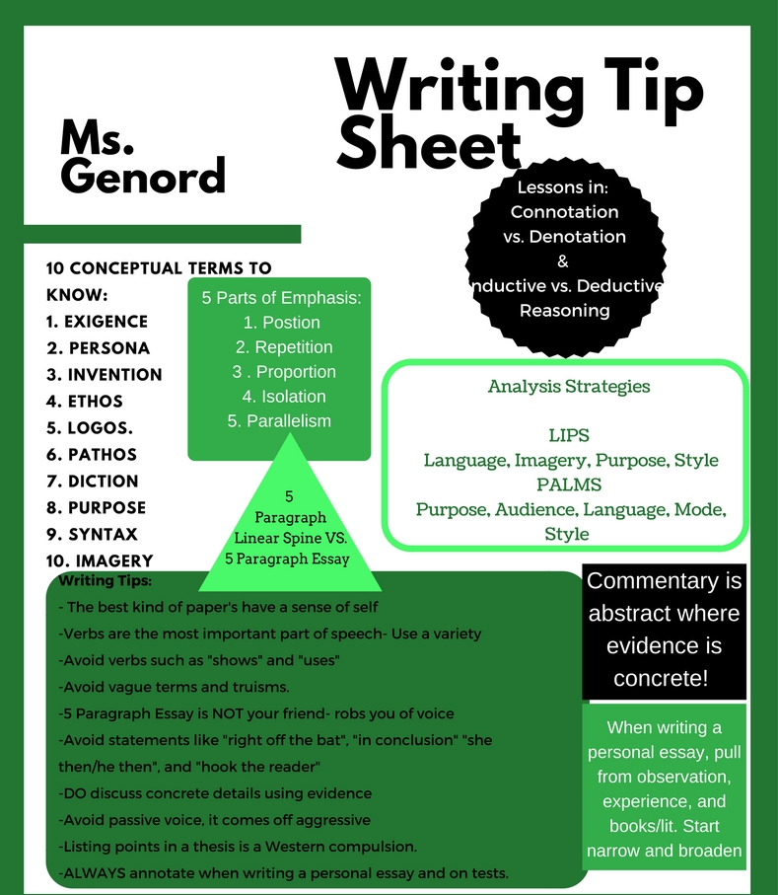


Name: ________________________Date:_____________Period:_____

RESPONSIBILITY NOTE (EXAMPLE)
Please stop what you are doing and make a better choice!

You are hereby notified that your behavior has been documented and cannot be allowed. If your behavior does not change, it may result in a referral, a phone call home, or a detention and could negatively affect your grade. A copy of this form will be available for your parent/guardian. Please consider the steps to change your behavior so that you can succeed in our classroom!

STUDENT BEHAVIOR
Check all behaviors that apply:

______: disrupting class
______: verbal dispute with classmate
______: technology infraction
______: socializing instead of working
______: mistreating school property
______: sleeping/not participating
______: disrespectful to teacher
______: inappropriate language
Other:

TEACHER REACTION
Ms. Genord will check all that apply:

______: seat change
______: isolation/sent to hallway
______: verbal warning
______: redirection
______: proximity control
______: private conference
Other:

Consequences
___Detention ~ Date Completed___________
___Parent Contact ~ Date __________
___Parent Conference ~ Date_________
___Referral ~ Date________
STUDENT REFLECTION
- Why did I behave in this manner?

- What change do I need to make?

- Will you be able to do it? _____Yes ______No
- I need to see the teacher _____Yes ______No

Student Signature: _________________ Teacher Initials: __________ Date:______

Ms. Genord English Language Arts

Syllabus Contract

(Please turn in this page for your first homework grade! A freebie)

Class & Period: ________________

I, ___________________________________________________, received a copy of Ms. Genord’s syllabus, and I had ample time to read it, ask questions, and make suggestions for amendment. I understand that this syllabus is an obligatory document to which Ms. Genord is committed just as much as I.

Signature: ___________________ Date:_______________
Parent Version

Please have a parent or guardian sign below if they agree to this statement:

I have read the syllabus for this course, and I agree to assist my student in achieving high academic potential. I am willing to openly communicate with Ms. Genord about any questions, concerns, and feedback for this course.

Signature: ___________________ Date:_______________

Parent Contact Information
I like to remain in contact with parents throughout the semester by sending out a monthly newsletter. The newsletter covers what we are doing and accomplishing in class. I will either send the letter home with your student or electronically via email. Please fill in any contact information where I might reach you during the semester:
Name
Phone | ( )
Email address | email account: ____________________@_____________

Vocabulary Books: Within the first 2 weeks of school, students are required to purchase a vocabulary book. The ISBN # for the books is: 978-0821571118
Be sure to purchase Level F!

Course Schedule:
1st Semester:
Unit 1: Fate/Free Will- Main Work: Macbeth September- October
William Shakespeare | Macbeth
Ambrose Bierce | Occurrence at Owl Creek Bridge
Jonathan Edwards | Sinners in the Hands of an Angry God
Robert Browning & Elizabeth Browning | Selected poems
Dante Rossetti | My Sister’s Sleep
Ernest Hemingway | The Short Happy Life of Francis Macomber

Unit 2: Identity Major Work: The Odyssey October- December
Homer | The Odyssey
Oscar Wilde | My Voice, Her Voice
Kate Chopin | Story of an Hour
Kurt Vonnegut | Harrison Bergeron
Henry David Thoreau | Selections from Walden
Dante Rossetti | The Blessed Damozel
Lord Alfred Tennyson | Ulysses, The Lady of Shallot

2nd Semester:
Charles Dickens | Great Expectations
Geoffrey Chaucer | The Canterbury Tales
Zora Neale Hurston | How it feels to be the colored me
Katherine Mansfield | The Doll’s House
Flannery O’Connor | Everything that Rises Must Converge
Thomas Hardy | The Darkling Thrush
Unit 3: Social Class Major Work: Great Expectations January-March

Unit 4: American Dream Major Work: Great Gatsby April-June
F. Scott Fitzgerald | The Great Gatsby
Langston Hughes | Dreams Deferred
William Faulkner | A Rose for Emily
Anzia Yezerska | America & I
Ronald Reagan | A Time for Choosing
Matthew Arnold  Hardy  Hopkins | Dover Beach  The Convergence of Twain  Dun Scotus’s Oxford
Each month I will hand out a calendar giving a more detailed assignment and reading schedule***

